Families & Communities
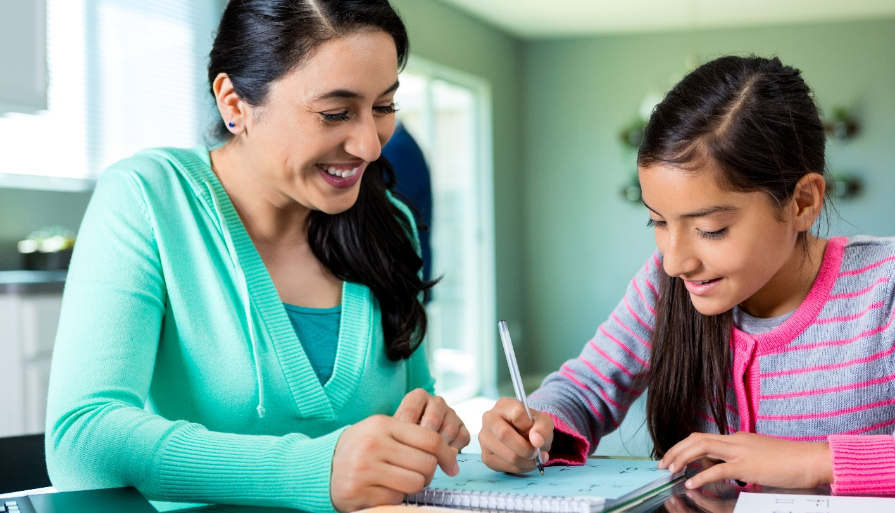
Celebrating & Supporting School Efforts!
Recently, the Florida Positive Behavioral Interventions and Support project (FLPBIS) awarded Royal Palm Exceptional Center 2020-2021 PBIS Model School status, recognizing our efforts to enhance student quality of life by implementing a Positive Behavioral Interventions and Support (PBIS) framework. As a PBIS Model School, we demonstrate a commitment to positive outcomes for all students!
What is PBIS?
PBIS is a set of strategies based in behavioral and biomedical science that enhances student quality of life and reduces problem behaviors. National research shows that full implementation of this framework leads to improved student outcomes. By establishing this framework, we are developing skills, making changes to the school environment, acknowledging appropriate behavior, and using data to identify supports for our students.
PBIS Framework | PBIS Goals
- Build safe, positive school climates  - Enhance and support effective school systems  - Include all stakeholder input and support  - Faculty & staff  - Students & families  - Community members | - Create environments that help students achieve success  - Develop positive, supportive relationships among stakeholders  - Prevent problem behaviors from occurring  - Teach appropriate behaviors  - Acknowledge appropriate behaviors of all stakeholders
Family and Community Members as Partners
As a part of these efforts, time and resources are dedicated to student, family, and community relationships.
Close participation of family and community members is crucial to success for students.

What can you do as a family member to support PBIS?
- Share your knowledge about how your child learns best and ways for supporting your child’s behavior, including background and cultural information, with your child’s teacher and school staff.
- Ask your child’s teacher about options for ensuring that home-school communication is maintained and that positive experiences, as well as any concerns, can be discussed proactively.
- Express your interest in your child’s education to your child and to his/her teacher. Talk to your child about the importance of education and positive behavior. Ask your child for specific examples that illustrate behavior demonstrating Tier 1 expectations throughout their day (e.g., “How did you show Respectful behavior during math today?”)
- Express your interest in the success of the school by reaching out to your child’s principal and classroom teacher to ask for options for engaging with and participating in areas of importance to the school.
- Share your understanding of issues your child may be facing that could impact his or her behavior with your child’s teacher. Ask your child’s principal and teacher how you can help to inform problem-solving efforts by sharing your understanding of issues facing the school and community.

What can you do as a community member to support PBIS?
- Share knowledge about community resources with school staff and family members.
- Provide and support the school’s access to resources
- Look for opportunities to reinforce behavioral expectations and provide acknowledgements to students within community settings

Recognizing Hard Work
As a result of our work, Royal Palm Exceptional Center is being recognized by the FLPBIS Project as a 2020-2021 PBIS Model School. To earn this achievement, schools must meet specific criteria that can be found on the FLPBIS Project website. This award demonstrates our commitment to positive outcomes for all students and helps us celebrate our efforts as we continue to strive for the highest quality implementation of PBIS.
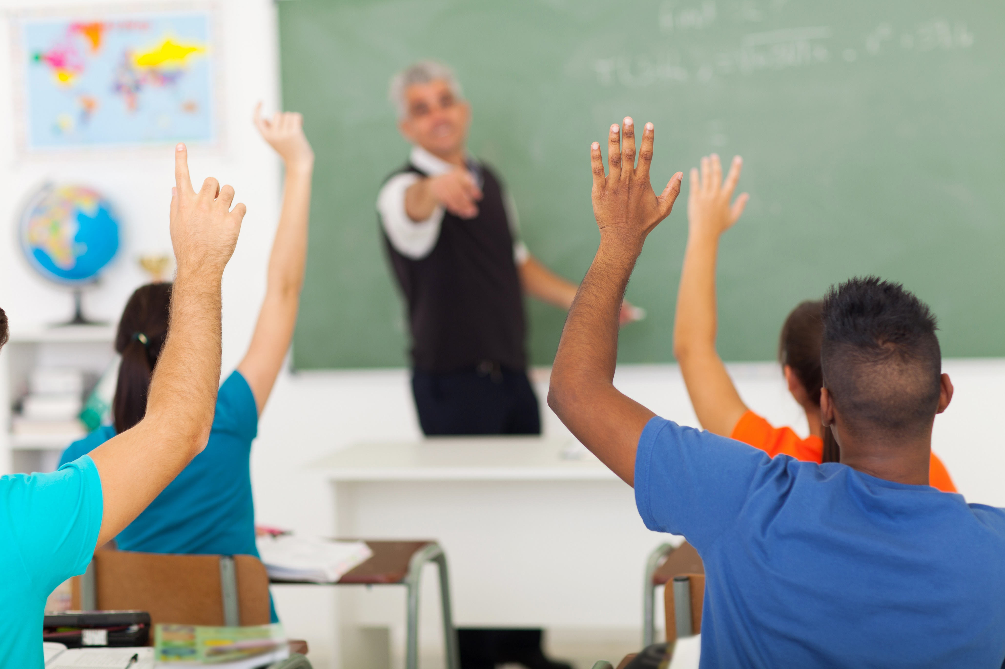
For more information on our efforts, visit roy.leeschools.net. To learn more about the FLPBIS Project Model School program, visit www.flpbis.org
